Assessment 3 – Installation & Usage Guide

Notice: This document refers to a prototype development version of the software. As a result, Visual Studio 2017 (any edition) is required to be installed on the target computer prior.

Contents

Section A: Ensuring ASP.NET is installed 2

Section B: Initial setup and compilation of the software 3

Section C: Running the software and logging in 4

Section D: The user interface 5

Section E: Assigning incidents to technicians 6

# Section A: Ensuring ASP.NET is installed

As the software is an ASP.NET application, ASP.NET is required to be installed in order for it to function. If you chose to install ASP.NET development tools while installing Visual Studio, you may skip this section.

1. In Visual Studio, choose *Tools -> Extensions and Updates.*
2. Install *Microsoft ASP.NET and Web Tools*, along with *Microsoft ASP.NET Web Frameworks and Tools*.

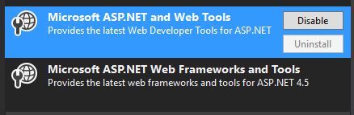

1. With these two extensions installed, you should be fully prepared to begin setting up the software.

# Section B: Initial setup and compilation of the software

The prototype version of the software is distributed in the form of a compressed Visual Studio project. In order to use the software, you will need to decompress this project and compile it.

1. Locate *AS3 - Project.zip* and extract it to a non-temporary location using your archiver tool of choice.
2. Either double-click on *Assessment3.sln*, or open it manually inside of Visual Studio.



1. Within Visual Studio with the project open, right click on the solution and select *Restore NuGet Packages.*

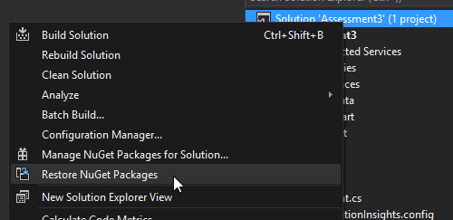

1. Wait for the package restoration process to complete.
2. Right click on the solution once more, and select *Build Solution*.

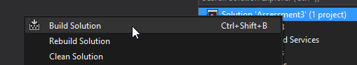

1. Once the build has completed, you should be able to move on to running the software.

# Section C: Running the software and logging in

After the software has been compiled, running it is a simple process.

1. At the top of the Visual Studio window, click on the Run button, which should appear as a green arrow next to the name of your preferred web browser.



1. Your browser should then open to the login screen, and the server machine you are running the software on should be accessible from client computers.
2. To log in, simply enter the user ID of either a customer, technician or administrator. Then enter the account’s password and click the login button.

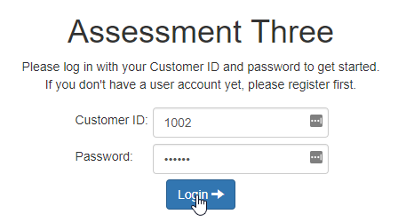

# Section D: The user interface

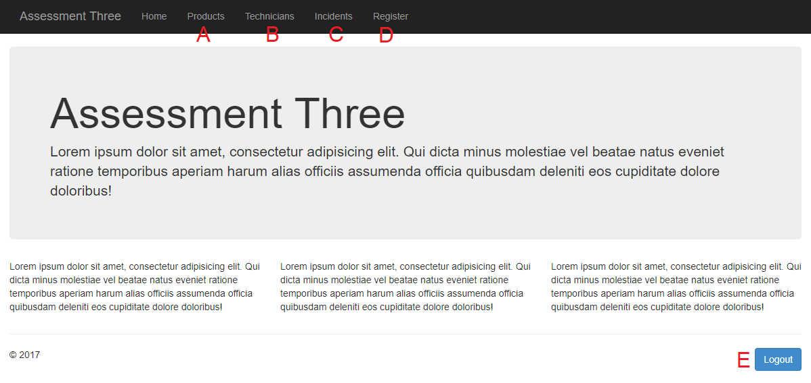

|  |  |  |  |
| --- | --- | --- | --- |
|  | Customer | Technician | Administrator |
| Fig. A | View all products | | View, edit, add and delete products |
| Fig. B | View all technicians | | View, edit, add and delete technicians |
| Fig. C | View all incidents | View, edit, add and delete incidents | |
| Fig. D | N/A | View and add product registrations | |
| Fig. E | Logs out of the currently active account and returns to the login screen | | |

# Section E: Assigning incidents to technicians

1. Enter the incidents tab (section D, figure C).
2. Locate the incident you wish to assign a technician to, and choose “edit.”

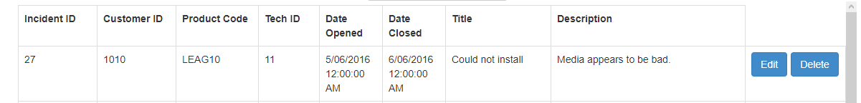

1. Select a new technician from the dropdown list, and click “apply.”

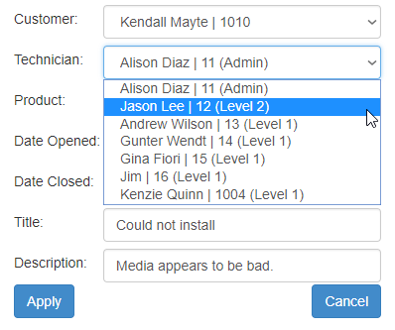

1. If an incident needs to be elevated to level 3, assign it to an administrator and make note of it in the description.